**Trinity Seven Season 2: Release Date and other details!** 

**Trinity Seven**, a Japanese romantic comedy grounded on the fantasy manga series of the same name written by Kenji Saito and illustrated by Akinari Nao. The manga **series** was first published on December 9, 2010.

**Trinity Seven Season 2: Release Date**

The first volume of the manga **series** was released on November 8, 2014. **Trinity Seven Season** 1 was streamed between October 2014 to December 2014.

Later on, **two** **films** based on the series were released. First was, **Trinity Seven** the Movie: The Eternal Library and the Alchemist Girl streamed on February 25, 2017. Then the creator of the **anime** announced on the official website of the manga on July 3, 2018, that another film production is in line titled **Trinity Seven**: Heavens Library & Crimson Lord which aired on March 29, 2019.

So, the otakus and weebs from all over the world are anticipating the filming of **Trinity Seven Season 2**. But there's no official announcement on the same. It solely depends on the creator when they want to renew the series for another **season**. We can only hope for some positive news.

**Trinity Seven season 2: Expected Cast**

Protagonists are likely to repeat their roles. There may be few additions but nothing has been unveiled yet. So, let's catch up with the lead characters.

**Arata Kasuga**: He lives in his hometown with his family and friends. But, when his town is destroyed and his loved ones are killed by an event, he joins the *Royal Biblia Academy* with the yearning to become a learned personality. In the academy he becomes friends with the **Trinity Seven** and with their help, he's shown trying to save his hometown, family, and friends.

Lilith Asami: A teacher at the Royal Biblia Academy, who helps Arata throughout the series to introduce him to the world of magic. Further, in the show, it's unveiled that she's Azazel Lilith, daughter of a demon king, whose memory is changed while she traveled between the two distinct spheres.

Arin Kannazuki: Another leading character in the show, a member of the **Trinity Seven**. It's unveiled that she has no memory before the age of eight unless the headmaster of the Royal Biblia Academy took her under the guidance and taught her everything. She's often shown to have feelings for Arata.

Levi Kazama: Levi, a member of the **Trinity Seven** and a friend of Arata at the Royal Biblia Academy, who's known to be among the world's top three fighters.

Yui Kurata: Yui, a member of the **Trinity Seven** and the closest friend of Levi who has the power to communicate through dreams.

Lieselotte Sherlock: Lieselotte, a member of the **Trinity Seven** and the Royal Biblia Academy and used to hold the second seat of the Royal Library Inspectors. Later on, it's unveiled that she has some criminal records in her past.

Mira Yamana: Mira, a member of the Trinity Seven and the Royal Biblia Academy, who's the head of the grimoire security.

Akio Fudou: Akio, a member of the Trinity Seven and the Royal Biblia Academy and handles grimoire security along with Mira. 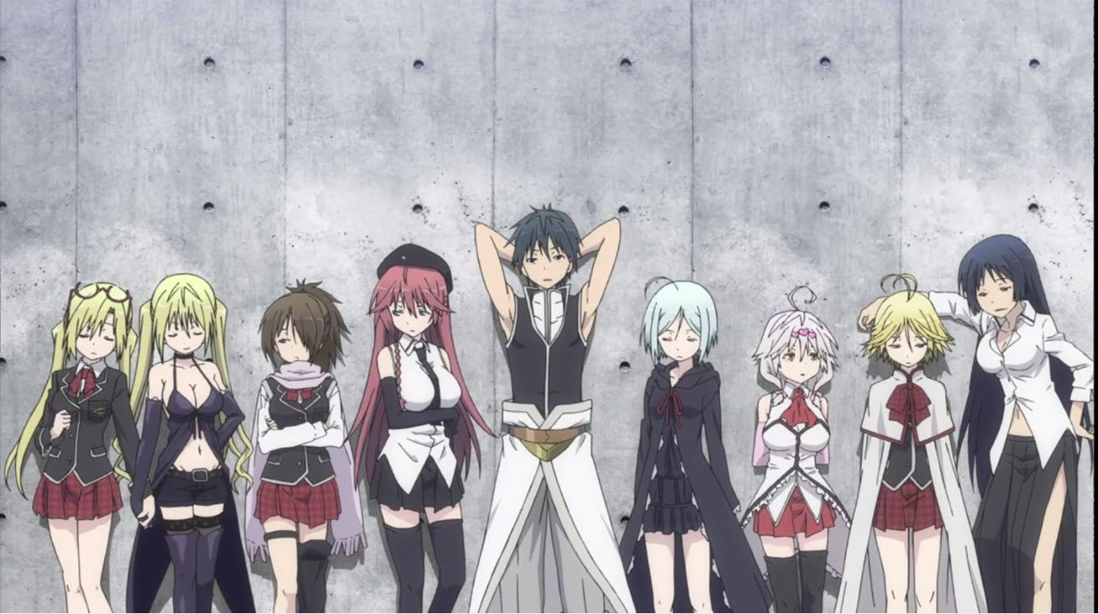

**Trinity Seven season 2: Expected Plot**

**Trinity Seven**'s plot revolves completely around magical ideas. It revolves around Arata Kasuga, a young boy who used to live happily in his hometown with his cousin and childhood friend, Hijiri Kasuga unless a breakdown phenomenon happens which destroys everything in his hometown and kills his friend and family members. Arata was about to be killed but he gets saved by Hijiri who hands over a grimoire to Arata just before her death, which prevents him from killed by that phenomenon.

While going through the pain of losing his family and friends, Arata wishes his life to go back to normal which triggers the grimoire unknowingly, and artificially his life goes back to normal, and then a magician Lilith Asami appears before him and everything which is artificially created is destroyed.

Then Lilith gives two options to Arata to choose from i.e., hand over the grimoire to her or die. He's not willing to choose any of them and later on some persuasion with Lilith he agrees on a third option of getting enrolled in a top-secret magic school, The Royal Biblia Academy where other students also study magic. Then along with the other six students, he forms the **Trinity Seven**, who's the known magician of the school, famous for having unique skills and power.

Then with the help of his friends, he plans to save his hometown, friends, and family members.